***Abstract***— **This is a proof-of-concept study for the development of a field-deployable and low-cost PCR thermocycler (FLC-PCR) to perform Polymerase Chain Reaction (PCR) for the rapid detection of environmental *E. coli*. Four efficient (77.1 W) peltier modules are used as the central temperature control unit. One 250 W silicone heating pad is used for the heating lid. The PID (proportional–integral–derivative) control algorithm for the thermocycles is implemented by a low-cost 8-bit, 16 MHz microcontroller (ATMEGA328P-PU). ybbW and uidA genes from specific *E. coli* colonies were used as amplicons for the PCR reactions that were carried out by a commercial PCR machine (Bio-Rad) and our FLC-PCR thermocycler. The heating and cooling speeds averaged 1.11 ± 0.33°C/s which is on a par with the commercial bench-top PCR thermocycler and the efficiency of the heating lid outperformed the Bio-Rad PCR thermocycler. The overall cost of the system is lower than $200 which is more than ten times lower than commercially available units. The heating block can be customized to accommodate different PCR tubes and even microfluidic chambers. An 8000 W portable power generator will be used as the power supply for field studies.**

**A Field-Deployable and Low-Cost PCR (FLC-PCR) Thermocycler for the Rapid Detection of Environmental *E. coli***

*1 James Ferguson, 1 Jesse Duran, 2 Wesley Killinen, 1 Jason Wagner, 2 Caroline Kulesza, 1 Christie Chatterley, and 1 Yiyan Li, Member, IEEE*

1 Department of Physics and Engineering, Fort Lewis College, Durango, CO, USA

2 Department of Biology, Fort Lewis College, Durango, CO, USA

# Introduction

Polymerase chain reaction (PCR) is a vital microbiology technique in which a DNA sequence is amplified by being copied millions of times [1]. PCR has broad applications in bacteria testing, including source-tracking and identification of pathogenic strains in surface waters or blood streams [2]. By detecting the presence of specific bacteria, treatment can be swifter and more effective.

PCR is implemented using a thermocycler which heats and cools water (or blood) samples mixed with reagents for 30 - 40 cycles. A thermocycler consists of two main components: a heating block to control the temperature of the samples and a heated lid to prevent condensation on the top of the vials. Many commercial thermocyclers are available on the market; however, they are expensive, immobile, or not customizable [3].

* This study is supported by the EPA P3 grant (SU83988001). James Ferguson and Jesse Duran are supported by the EPA P3 grant (SU83988001). Yiyan Li (corresponding author: 970-247-6574, yli@fortlewis.edu) is supported by the NSF PREM grant (#1827847), NSF REU grant (#1757953), and the EPA P3 grant (SU83988001).

We aimed to design the hardware and software for an efficient and low-cost thermocycler system and identify critical design parameters for a complete field-deployable version. This thermocycler will be used with PCR tubes or microfluidic chambers for both traditional PCR and the emerging ddPCR (droplet digital PCR) for large volume samples from the environment.

# Materials and Methods

*A. Hardware Design*

The ‘brain’ of the thermocycler is a low-cost, 8-bit, 16 MHz microcontroller (ATMEGA328P-PU) that controls the thermocycles of the peltier array and the heating lid. The cross-sectional view of the thermocycler prototype (Fig. 1a) shows the heating lid, the heating block, the peltiers, the heat sink, and the fan. Fig. 1b shows the top view of the 56-well aluminum heating block. Fig. 1c shows the microcontroller unit, the current drivers, and the digital circuits on an integrated PCB.

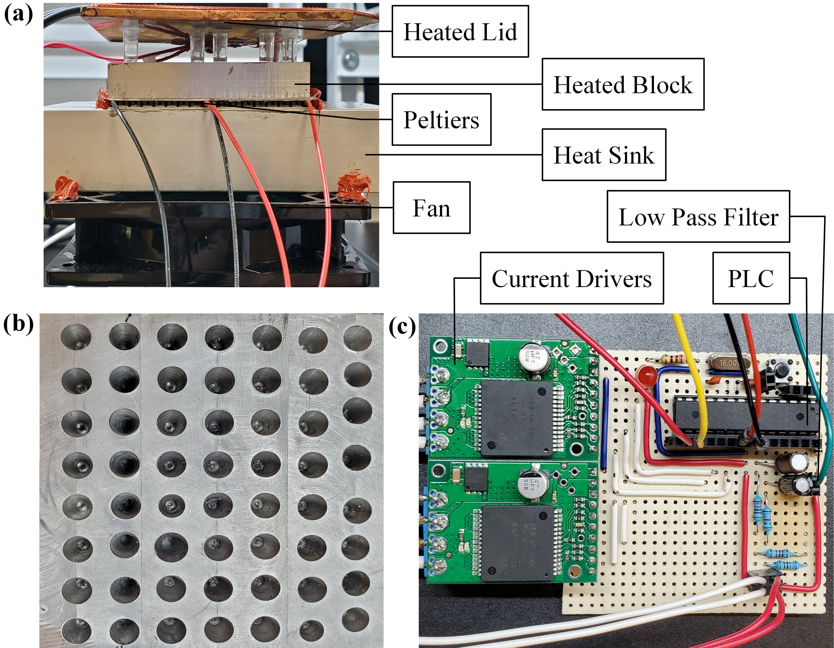

Fig.1 (a) Thermocycler setup. (b) Heating block wells. (c) The current drivers, the 8-bit microcontroller and its peripheral digital circuits, and the low pass filters (high frequency noise attenuator) mounted to a printed circuit board.

The microcontroller regulates the moment to moment temperature via four 12711-9L31-09CQ peltier modules and an AOLE ASH-25DA solid state relay (SSR) connected to a Zerostart 3400063 250 W silicone heating pad. The system diagram is shown in Fig. 2.

The 56-well heating block was constructed from a 6061 aluminium alloy block. Four peltiers were mounted in parallel, both electrically and physically, between the heating block and an extruded aluminum heatsink. A 120 mm 12 V fan was used for air circulation for the cooling process. Two VNH5019 current drivers regulate voltages across each peltier module. Depending on the polarity, the peltiers will either pump heat into or out of the block. The peltiers are powered using a 15 V 600 W power supply in the lab.

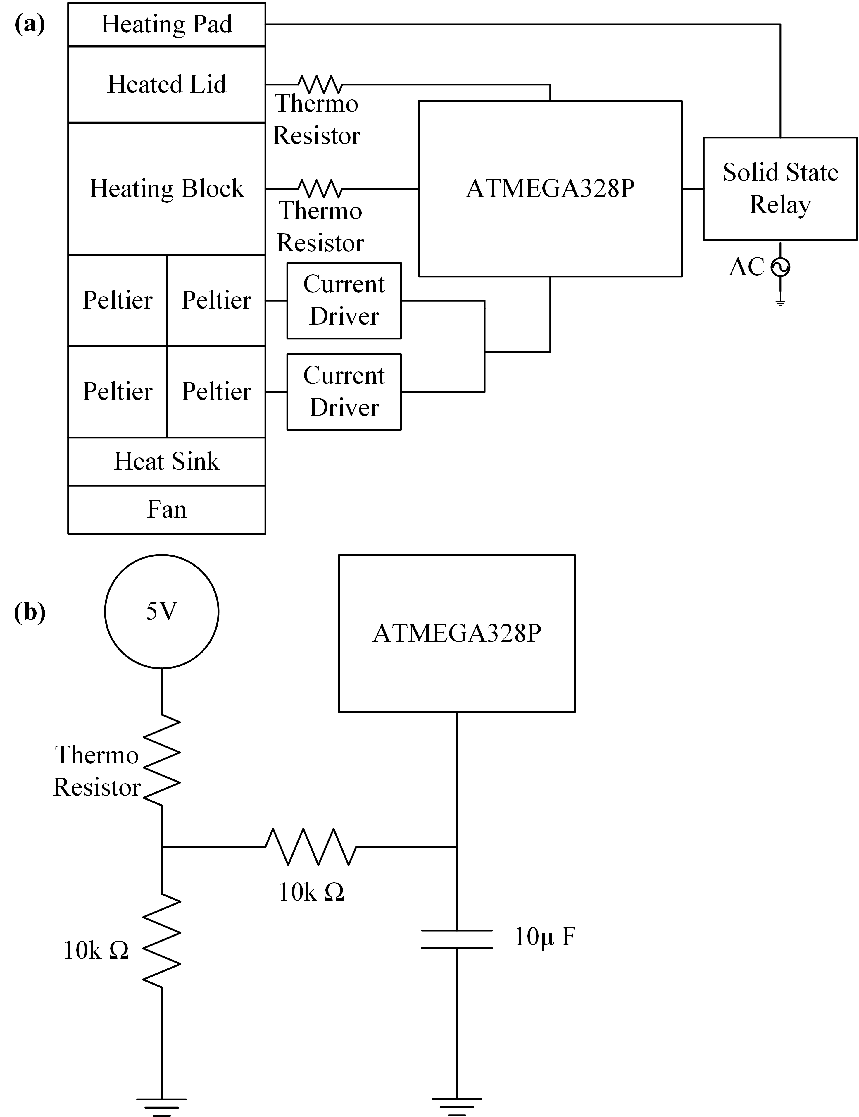

Fig. 2 (a) Thermocycler hardware connection schematic. (b) Low pass filter used by the thermoresistors to stabilize analog signals.

The heating lid is composed of two components, the silicone heating pad and a copper plate. The silicone pad is plugged into a 120 Vrms wall socket and connected to an SSR (solid state relay) which turns on the pad if the plate is less than 90°C. Temperatures were measured via thermoresistors on the bottom of the copper plate and inside a small hole in the heating block.

*B. Software Design*

The software consists of a Python GUI for real-time temperature tracking and control and a C++ script for the microcontroller. The GUI handles user interface and manages the cycle procedure (Fig. 3). Cycle steps are added to a cycle queue based on user defined parameters. Once the cycling process has begun cycle steps are de-queued and the cycle temperature at the front of the queue is sent via USB to the microcontroller to implement the C++ script.

The C++ script for the microcontroller uses an altered version of Proportional Integral Derivative (PID) control where multiple sets of PID constants are used to manage temperature. This was done to account for non-linearities in the heating and cooling process. PID constants were chosen with the following goals in mind: the system should be fast to improve total process time and be able to maintain accurate temperatures.

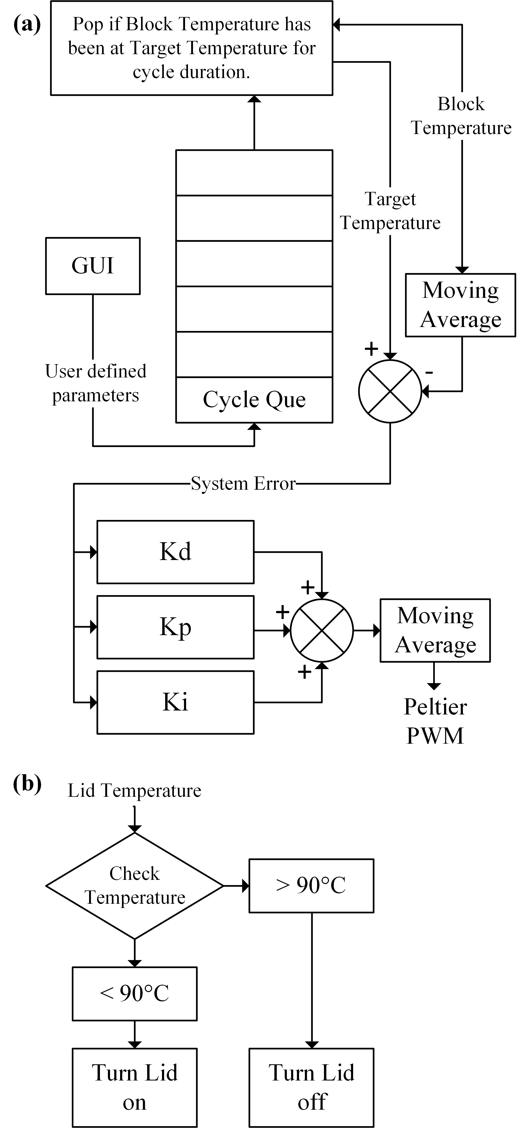

Fig. 3 Software overview. (a) Peltier control system, (b) Heated lid control system

It should also not oscillate so power consumption is reduced, and unnecessary waste heat is not generated, which would further hurt the ability of the system to cool. The constants used are described in Table 1.

Table 1 Gains for PID system

|  |  |  |  |
| --- | --- | --- | --- |
| Target Step | Kp | Ki | Kd |
| 94°C → 60.5°C | 19 | 0.2 | 10^7 |
| 60.5°C → 72°C | 9 | 0.17 | 10^7 |
| 72°C → 94°C | 9 | 0.4 | 10^7 |

After PID calculation, this signal is converted into pulse width modulation (PWM) and direction signals for the two VNH5019 chips.

Signal noise became a problem after increasing the derivative gain. To stop oscillation, the derivative gain needed to be very high which also caused some stability issues due to noise also being amplified. To reduce noise, low pass filters were applied to thermoresistor signals and moving averages were applied to the block temperature and peltier PWM.

*C. PCR Experiment*

Colony PCR was performed on *E. coli* K12 using primer pairs to amplify the ybbW or uidA gene. The ybbW primer sequences were designed using MacVector software v17.0.10. The ybbW primer sequences are as follows: ybbWforward, 5’-TCAGCGCCTTTTTCATTGCC-3’ and ybbWre­verse, 5’-CCGCGTAACATTGCAAACCA-3’. The uidA primer sequences were derived from a published study [2] and were as follows: uidAforward, 5’-CGGAAGCAACGCGTAAACTC-3’ and uidAre­verse, 5’-TGAGCGTCGCAGAACATTACA-3’.

All PCR reactions used OneTaq 2X Master Mix (NEB) and primers at 0.25 µM. Cycling conditions were 95 °C for 5 min, followed by 35 cycles of 95 °C for 1min, 60.5 °C for 1 min, 72°C for 1 min. Products were stored at 4 °C until analysis by 1% TBE agarose gel electrophoresis.

The same PCR experiments were carried out by the commercial BioRad PCR machine and our low-cost PCR thermocycler.

# Results

*A. Cycling Performance*

Fig. 4 shows one of the 35 cycles for the PCR experiments. The data was recorded by a Python GUI that directly interfaced with the hardware to record and display the data in real-time.

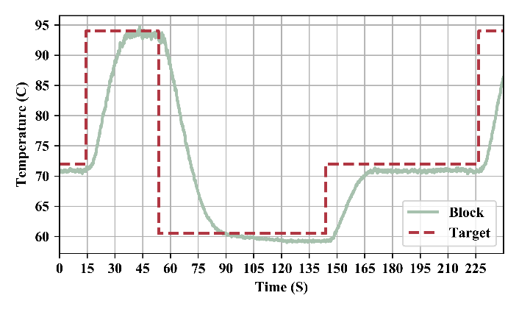

Fig. 4 A typical thermal cycle with target and measured heating block temperature for the experimental conditions.

The average time this system took to arrive within 2 °C of target temperature is presented in Table 2. There was no ramp for the start of the first cycle or for the end of the last cycle, only the middle 33 cycles were included in the average.

Table 2 Average system temperature ramp times.

|  |  |
| --- | --- |
| Target Step | Ramp Duration CI 95 |
| 94°C → 60.5°C | 29.94 ± 0.19 s |
| 60.5°C → 72°C | 23.33 ± 0.22 s |
| 72°C → 94°C | 20.44 ± 0.16 s |

*B. Heated Lid*

The heated lid is placed on top of the PCR tubes. The temperature control of the lid does not require a feedback algorithm. The target temperature of the lid is 90°C but the deviations at the beginning (Fig. 5) will not affect the reaction because the heat from the top is used to avoid vapor condensations.

The time it took to get the lid to target temperature was 69 seconds compared to 2 min 17s for the Bio-Rad T100 thermocycler. (Fig. 5)

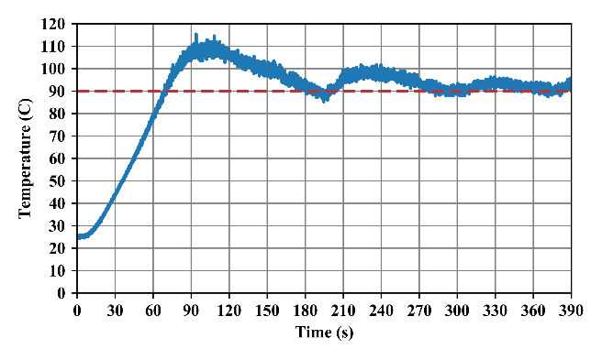

Fig. 5 Heated lid temperature warming from room temperature to target temperature of 90°C

The lid continued to heat after the SSR was switched off due to the residual heat in the silicon pad. After 300 seconds, the oscillation in temperature settled within 10°C above the target temperature (Fig. 5).

*C. Peltier Power Consumption*

As shown in Fig. 6, when increasing the number of peltiers physically in parallel and decreasing the applied voltage across them, both reduced power consumption and improved thermal performance resulting in improved efficacy.

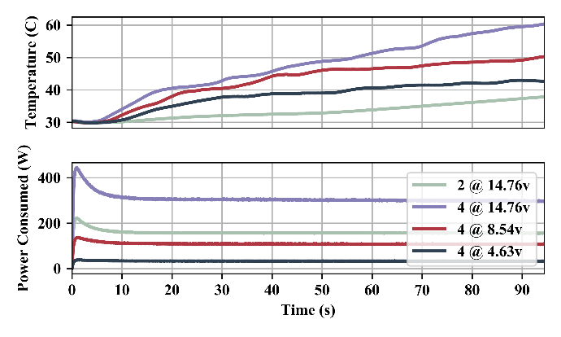

Fig. 6 Hot side temperature and maximum power consumption of various peltier configurations heating 16oz of tap water.

During cycle routine used in this study, this system consumed an average of 55.97 ± 0.39 watts with peak power consumption reaching 458.55 watts.

*D. PCR Reaction Results*

Fig. 7 shows the PCR gel images of the products from both the Bio-Rad PCR and our FLC-PCR thermocyclers. In both thermocyclers, amplification of ybbW yielded a specific product of 177bp and amplification of uidA yielded a specific product of 70 bp.

Smeared areas were observed in the gel that carries our FLC-PCR products. This may be attributed to poor heat transfer rate from the heating block to the PCR tubes. Calibrations of the liquid temperature inside the tubes and the body of the tubes will be performed using water-proof thermocouples to improve the performance of our FLC-PCR machine.



Fig. 7 Agarose gel electrophoresis analysis of ybbW and uidA PCR products generated in a Bio-Rad T100 thermocyler (left panel) and our system (right panel). PCR reactions containing template are noted (+), no template controls are noted (-). Bright band in 100bp ladder is 500bp long.

# Discussion

Our FLC-PCR system successfully amplified two signature *E. coli* genes within a shorter turnaround time compared to the commercial Bio-Rad PCR thermocycler. The FLC-PCR system had an average ramp rate of 1.11 ± 0.33°C/s. Compared to a Bio-Rad T100 Thermal Cycler which has an average ramp rate of 0.97 ± 0.23°C/s. The FLC-PCR system’s heated lid was faster. Ours took 69 seconds compared to the Bio-Rad PCR thermocycler which took 2 min 17s.

During system testing we noted that cooling performance would significantly slow over time for cycle procedures that ran at higher frequencies. It is believed that this was caused by the heatsink not being fast enough at dissipating heat. A more efficient heatsink can be used to replace the current one.

Overshoot of the heated lid temperature could be improved by adding PID control to reach the target temperature without overshoot. PWM may be used to simulate an analog signal going to the SSR. The PID system for the peltiers could also be better tuned to achieve faster speed and reduce steady state error as well as generalized to work with other cycle parameters. A redesigned heating block could be more space efficient allowing for less mass to be heated unnecessarily.

The system could also be improved by increasing the number of peltiers to achieve greater thermal performance.

# Acknowledgments

We want to thank the strong support from the FLC foundation for the materials and supplies for the senior seminar team. This publication was developed under Assistance Agreement No. SU83988001 awarded by the U.S. Environmental Protection Agency to Yiyan Li. It has not been formally reviewed by EPA. The views expressed in this document are solely those of Yiyan Li and do not necessarily reflect those of the Agency. EPA does not endorse any products or commercial services mentioned in this publication.

# References

[1] L. Garibyan and N. Avashia, "Research techniques made simple: polymerase chain reaction (PCR)," *The Journal of investigative dermatology,* vol. 133, p. e6, 2013.

[2] D. I. Walker, J. McQuillan, M. Taiwo, R. Parks, C. A. Stenton, H. Morgan*, et al.*, "A highly specific Escherichia coli qPCR and its comparison with existing methods for environmental waters," *Water research,* vol. 126, pp. 101-110, 2017.

[3] P. Belgrader, W. Benett, D. Hadley, J. Richards, P. Stratton, R. Mariella*, et al.*, "PCR detection of bacteria in seven minutes," *Science,* vol. 284, pp. 449-450, 1999.